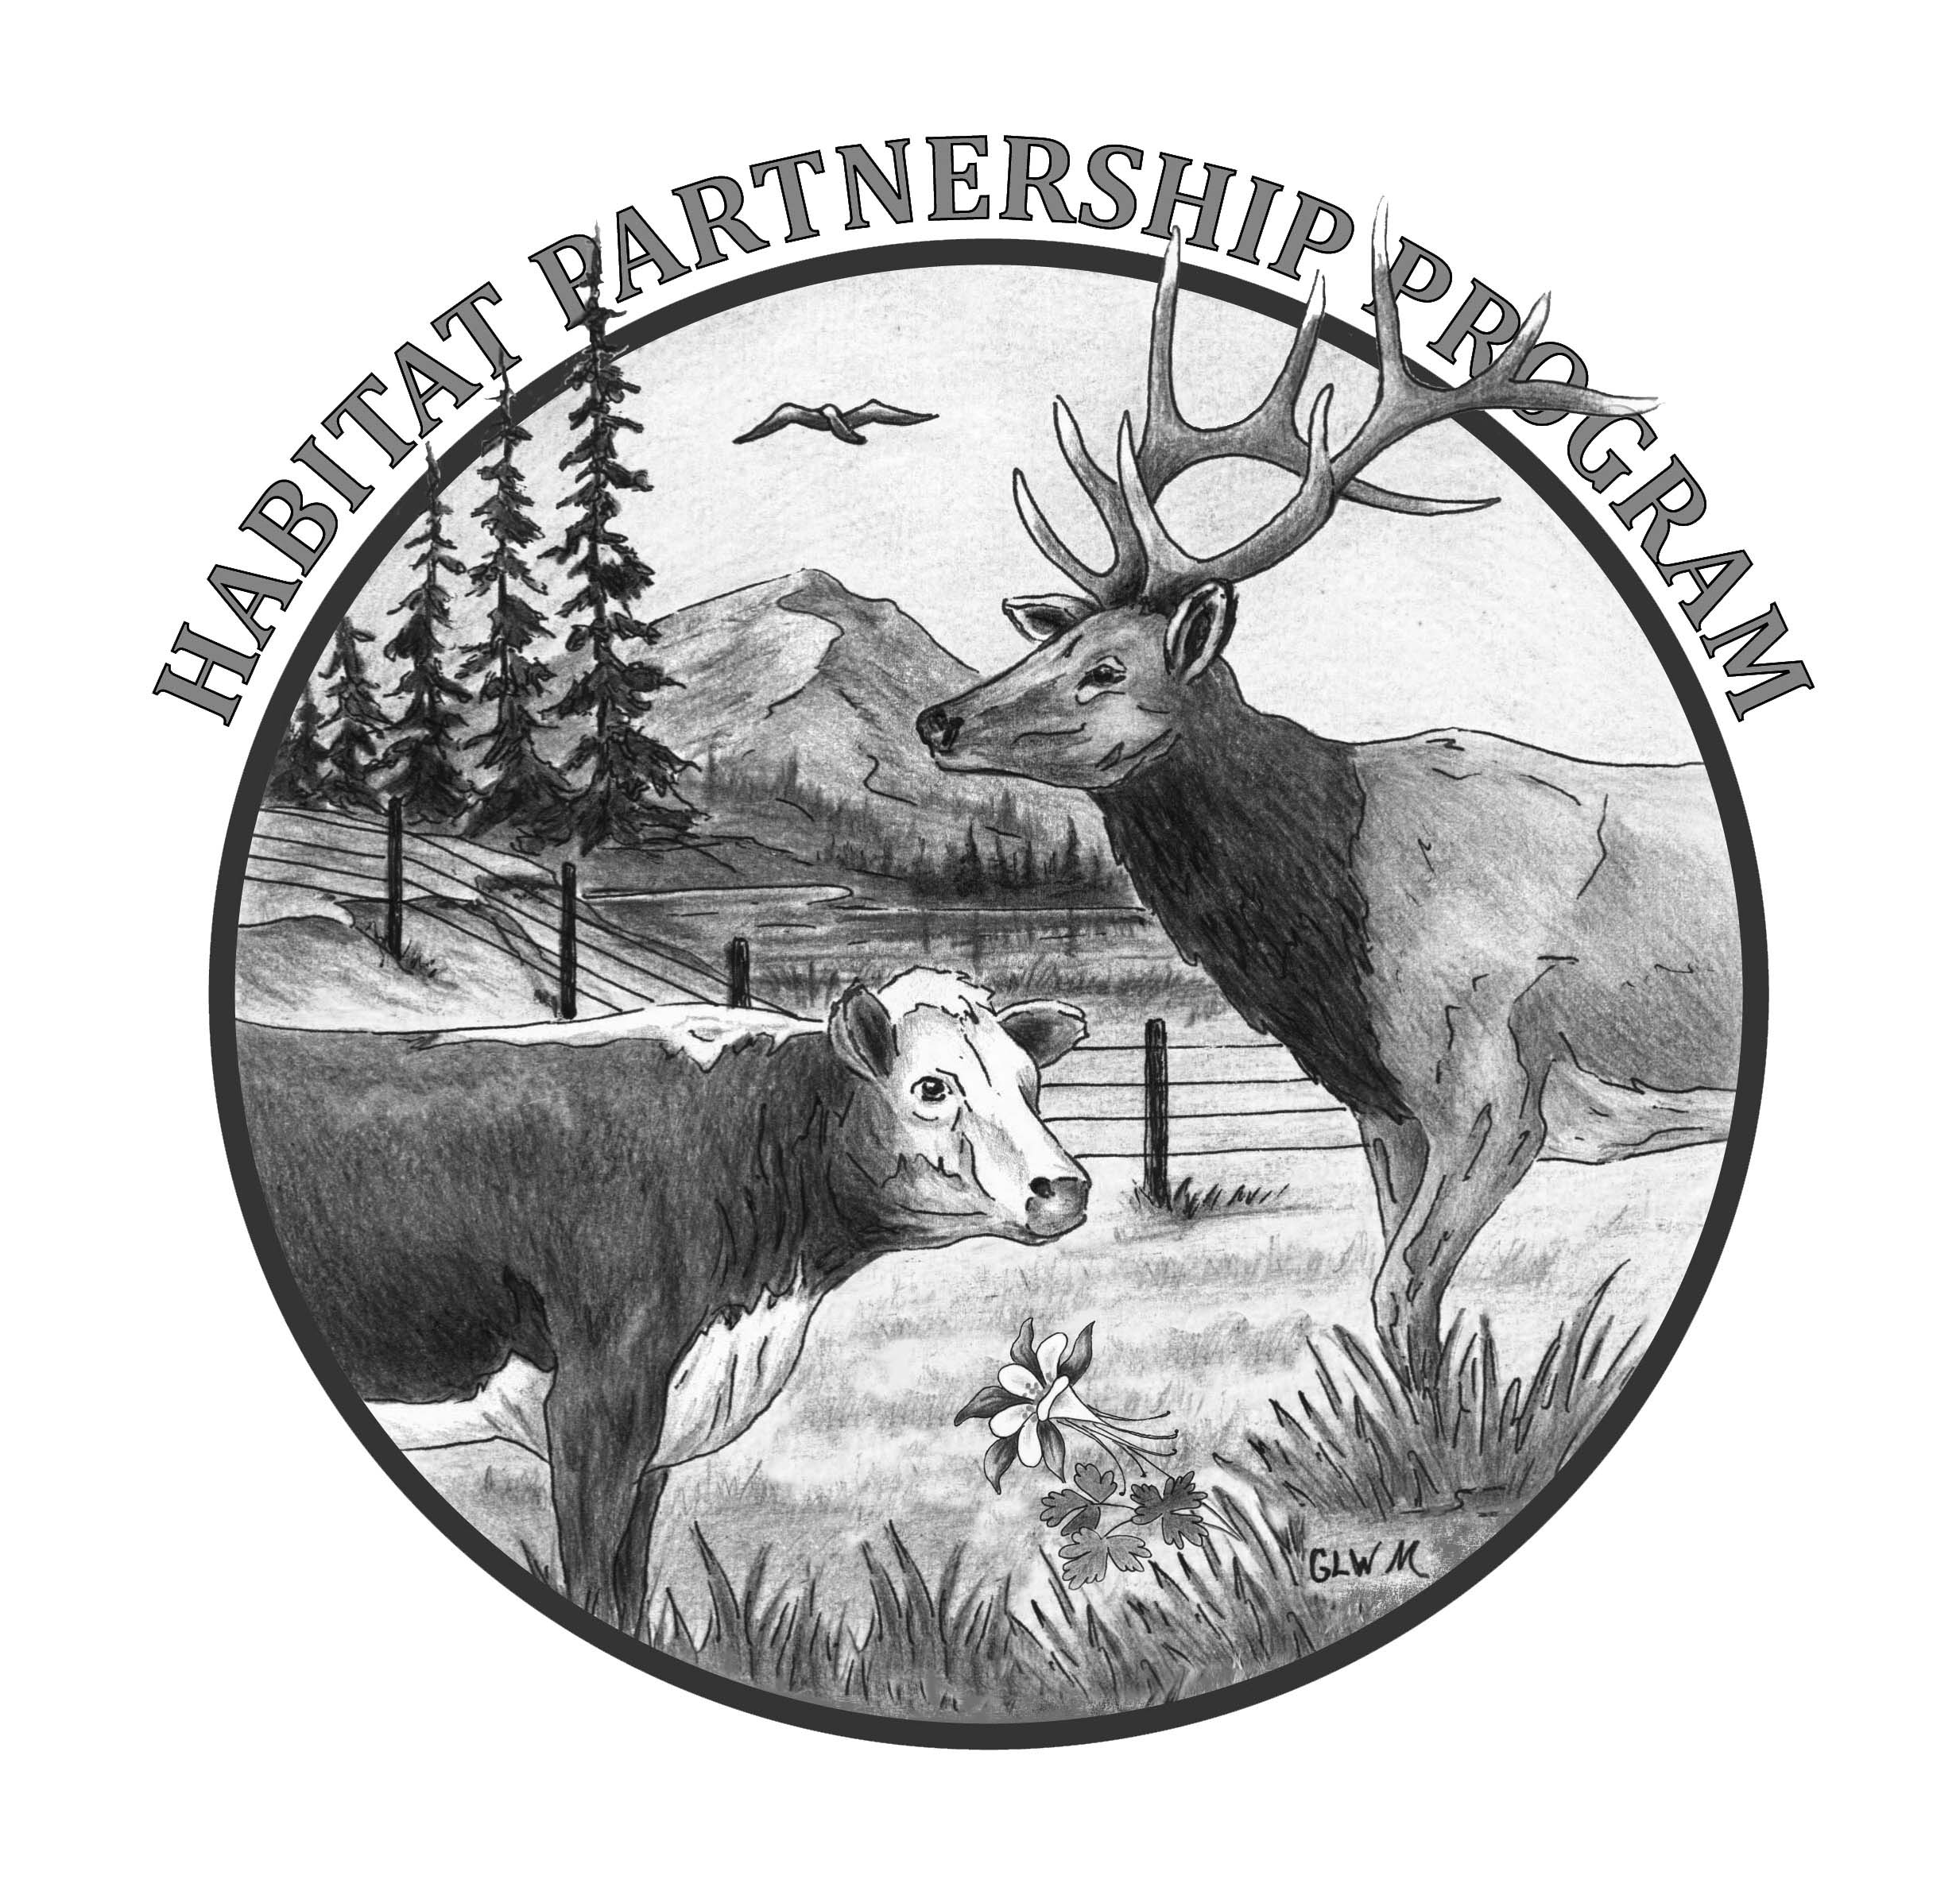
Colorado Parks and Wildlife
Habitat Partnership Program
Habitat Project Application
HPP Committee:

DWM:

I. CONTACT INFORMATION
Applicant (Main Contact)
Mailing Address
Daytime Phone # Secondary Phone # Email:

II. PROPERTY and PROJECT INFORMATION
Property Name and Address |  |  | Project Name
Project Location | County | UTM (NAD 83) E N
Project Location | NOTE: UTM’s required for the project site only, please do not list the location of your entire property
.
Property and Project Acreage Information | Private | Total Acres (Own Manage Lease-Owner:______________________)  Total Project Acres # Irrigated # Dryland # Woodland
Property and Project Acreage Information | Public | Acres | BLM USFS CPW SLB ____________  NOTE: Projects on CPW owned/controlled property require prior approval before committee review.

III. PROPOSED PROJECT FUNDING (Do not include money from previous or future projects/phases)
- TOTAL HPP Contribution Being Requested $  **Requests >$5k require additional approval BEFORE work can begin** |  |  | HPP is paying for labor materials or reimbursing the landowner
2. Project Cooperators/Partners | Match $ | In Kind $ | In Kind Hours
Landowner/Land Manager/Applicant | $ $
What will the Contribution be Used For?
Partner 1 | $ $
What will the Contribution be Used For?
Partner 2 | $ $
What will the Contribution be Used For?
Partner 3 | $ $
What will the Contribution be Used For?
GRAND TOTAL (1+2) $ $ |  |  | Hours

Match $ - real dollars paid to a 3rd party as a part of the cooperator’s contribution
In Kind $ - the value of services or labor that the landowner or cooperator contributes as determined by them.
In Kind Hours – the amount of time that a cooperator contributes to the project as their partnership contribution.
*Do not count both in kind $ and in kind hours for the same work.

EVALUATION AND JUSTIFICATION OF PROPOSED PROJECT

HPP assists agricultural landowners with conflicts caused by deer, elk, pronghorn and moose and to assist CPW achieve management objectives for those same species. Your project must meet at least one of these purposes in order to be considered. Projects that don’t meet these requirements will not be considered.

Which purpose of HPP does your project fit into? | Agricultural conflict caused by deer, elk, pronghorn or moose  Assist CPW achieve deer, elk, pronghorn or moose mgmt objs

Describe your project and the need for it.

If a conflict project, what are the benefits to the landowner?

If a management objective project, what will be accomplished?

Describe how the project will be monitored for success.

Will your project change big-game distribution or reduce game damage payments? | Yes-Describe:  No

If on private land, does the landowner allow hunting? | Yes Explanation: (who’s allowed, special restrictions, fees, etc)  No

If a conservation easement is on the property, has the easement holder approved of your project? | Yes Written approval from the easement holder may be required; please  No check with your committee

Is your project within state or federally designated habitat for either Gunnison or Greater Sage Grouse? | Yes for Gunnison or Greater Sage Grouse  No, not within designated habitat for either  Name of person making determination  OK to proceed? Yes No
NOTE: To determine if your project is within designated habitat, please check with your DWM or HPP administrative assistant. If your project is within designated habitat, further reviews may be needed before HPP can approve your project. Please plan ahead and allow for adequate time for this review.

Conflict Wildlife | Elk Deer Pronghorn Moose
Habitat Type | Ag Crop Aspen Conifer Forest Irrigated Hay Meadow
Habitat Type | Mtn Shrub Pinyon/Juniper Riparian Sagebrush Wetland

Habitat Use | Elk  Deer  Pronghorn  Moose | Winter Summer Fall Spring

Please mark the boxes that best describe your proposed habitat project:

Seeding Fire Grazing Management Fertilization
Weed Treatment Tree/Shrub Control Water Development
Spot spray? Mechanical or Hand Cutting? Pond cleaning, well drilling, pipeline, etc?

# of Treated Acres or Water Developments that HPP is paying for?

# of Treated Acres or Water Developments that other partners or the landowner is paying for?
This is in addition to what HPP is paying for
Please itemize what you are asking HPP to buy/reimburse for your project.
A formal quote of costs from the vendor/contractor for your project may be needed.
Quantity (lbs/hrs/gal/  acres) | Unit  (lbs/gal/  /acres/box) | Description  (type and amount per acre if applicable) | Unit Cost | Amount
 | TOTAL (Must Match HPP Cost #1 from page 1) |  | $
Tentative Start Date: Probable Completion Date:

DWM Name: Contacted/Reviewed/Support: Yes No
Landowner/Land Manager/Applicant Signature and Date: (Please check the boxes below)

HPP is only providing project funding based on the application submitted and final committee approval.
Any local, state or federal permits required for this project are my responsibility to obtain prior to the project starting.
I understand any money paid to me by the State of Colorado may result in a 1099 being issued to me.
Increases in project costs without prior HPP approval will be my responsibility.
I give my permission to HPP to use my personal and project information in maps and other program materials that may be shown to the public

__________________________________________________________________
Landowner Signature Date

NOTE: Your local committee may have specific project requirements, ie. before and after photos, soils test for fertilizer requests, ‘wildlife friendly’ fence specifications, minimum acreage, hunting allowed, DWM review, etc. Please check with them to see if your property and your project meet their specific conditions.

2/2019

