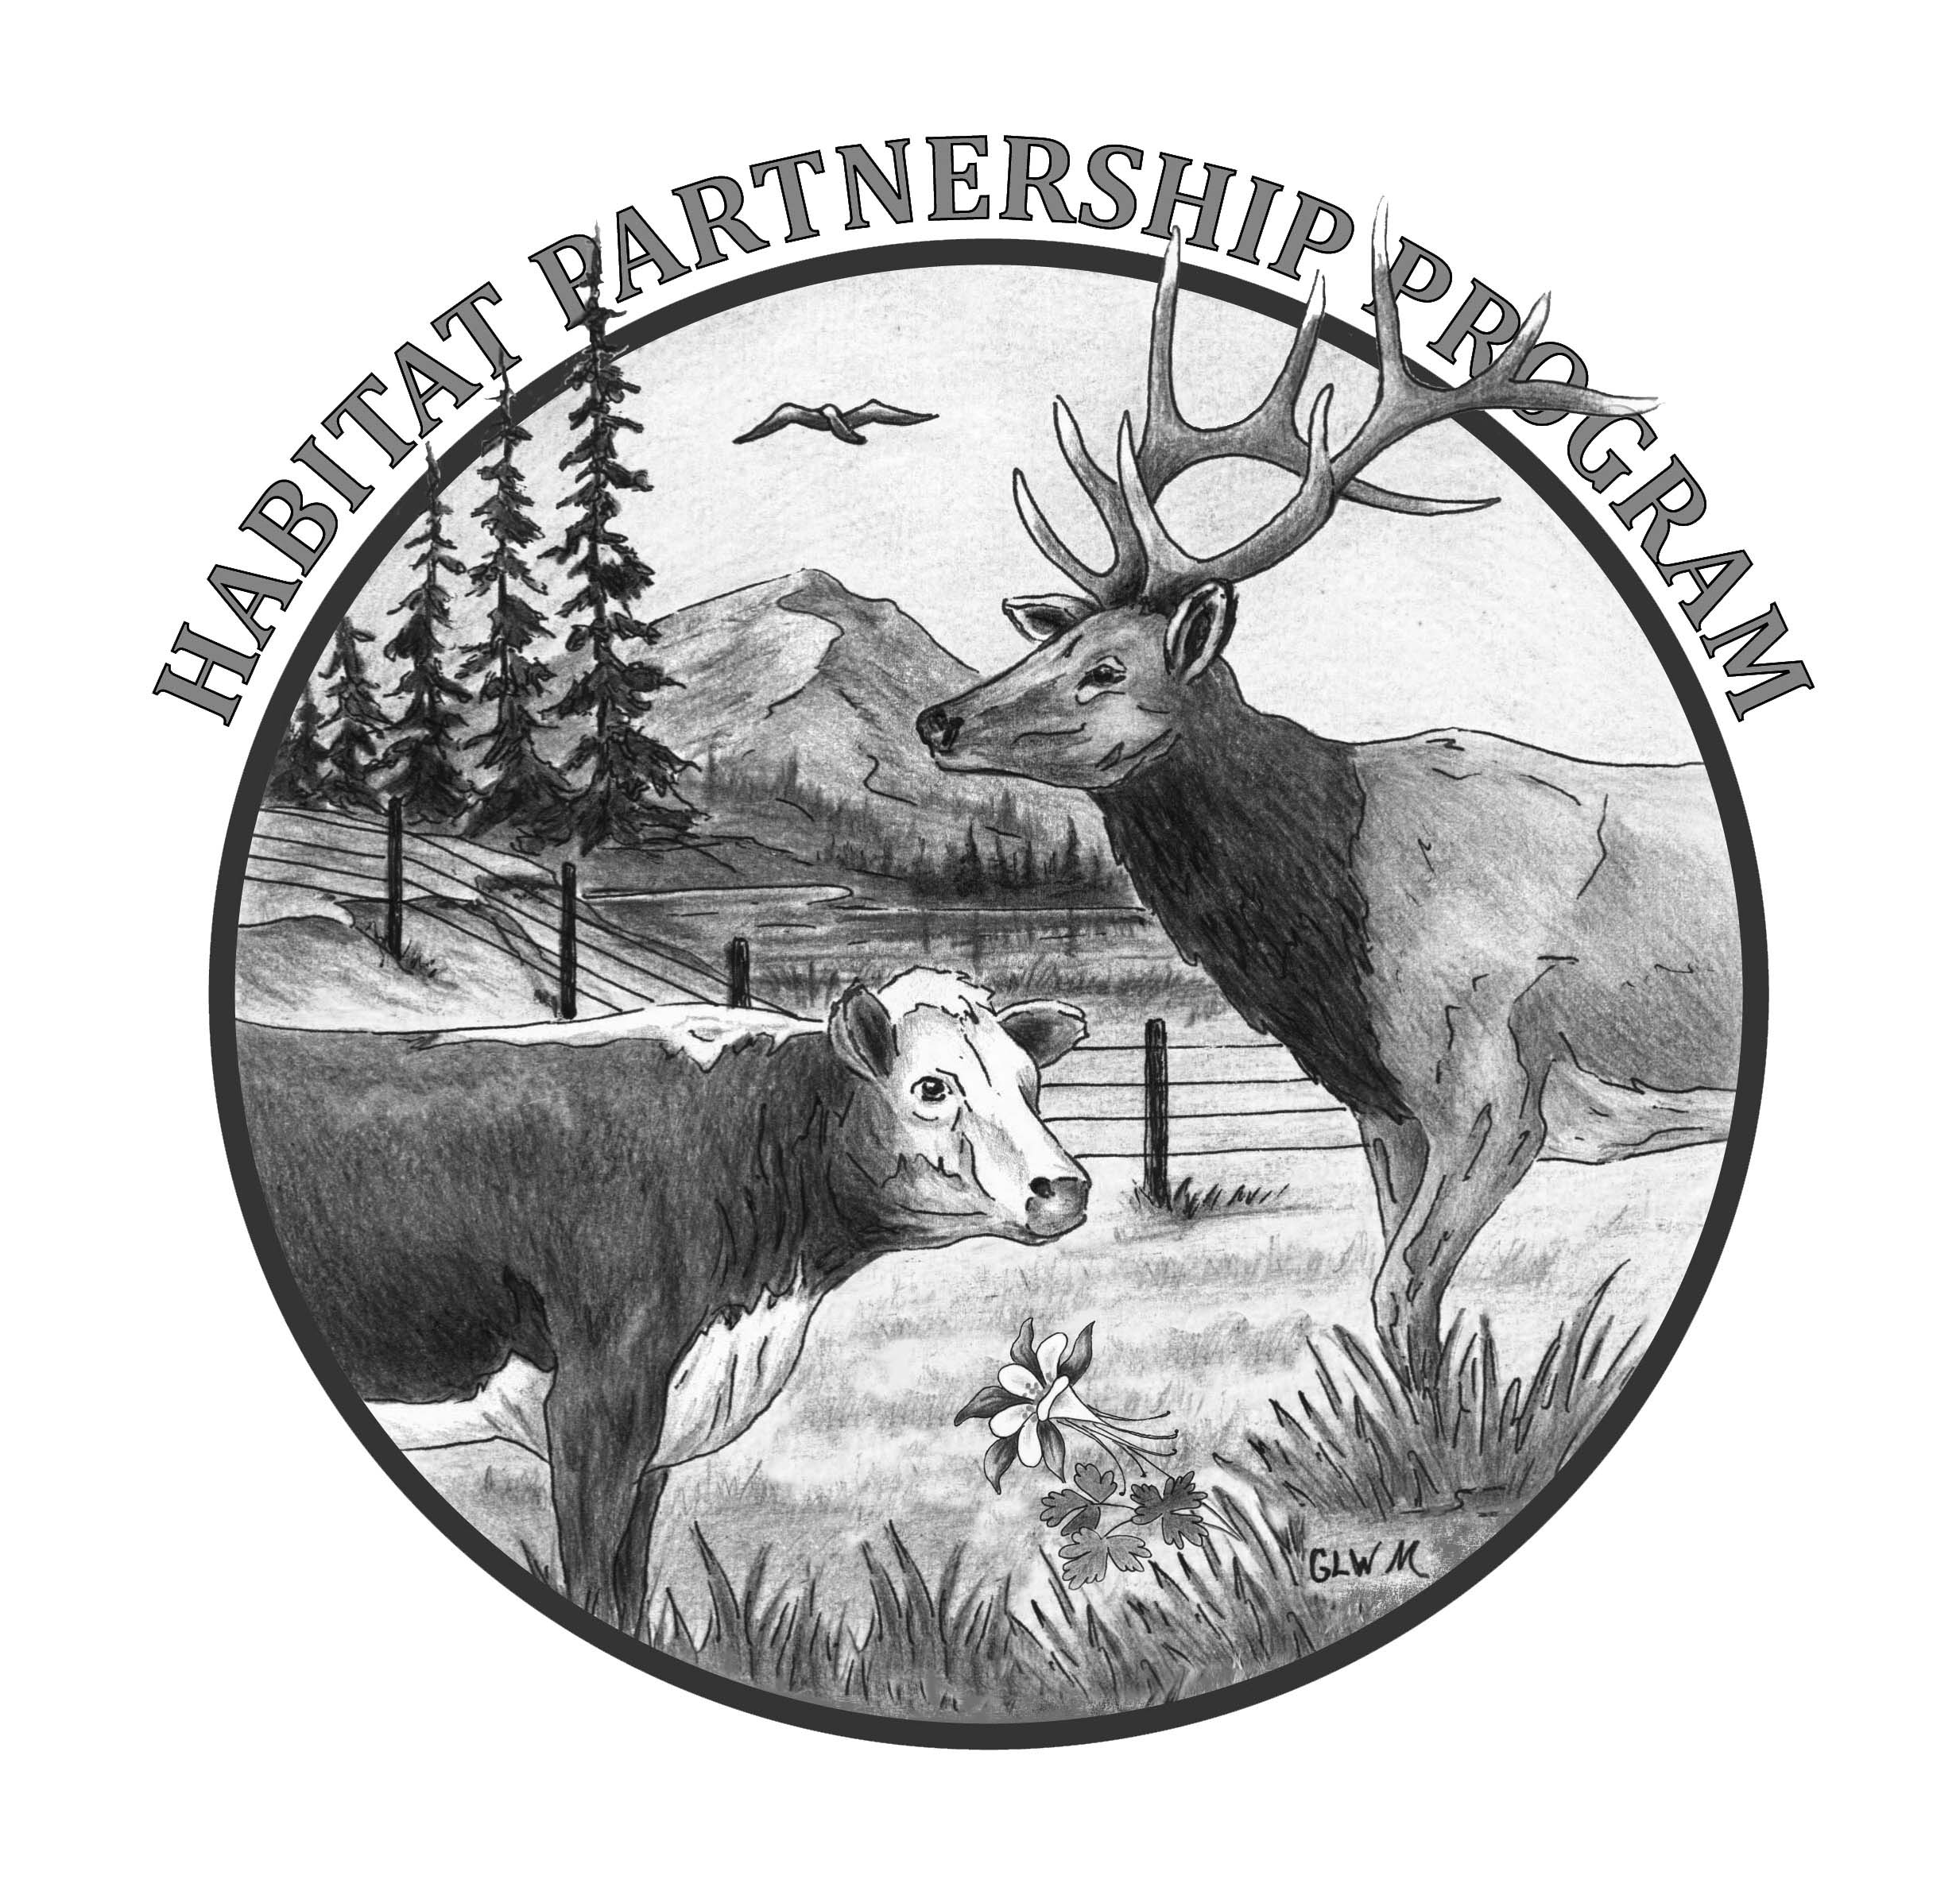
Colorado Parks and Wildlife
Habitat Partnership Program
Monitoring or Research Project Application
HPP Committee:

DWM:

I. CONTACT INFORMATION
Applicant Name (Main Contact)
Mailing Address
Daytime Phone # |  | Alternate Phone # | Email

II. PROPERTY and PROJECT INFORMATION
Property Name and Address |  |  | Project Name
Project Location | County | UTM E N Do Not Use T,R,S
Project Location | Other Location Information
NOTE: UTM’s required for the project site only, please do not list the location of your entire property.
Property and Project Acreage Information | Private | Total Acres Involved in Project
Property and Project Acreage Information | Public | Acres | BLM USFS CPW SLB ____________

III. PROPOSED PROJECT FUNDING (Do not include $ from previous or future projects/phases)
- TOTAL HPP Contribution Being Requested $  **Requests >$5k require additional approval BEFORE work can begin** |  |  | HPP is paying for labor materials or reimbursing the landowner
2. Project Cooperators/Partners | Match $ | In Kind $ | In Kind Hours
Landowner/Land Manager/Applicant | $ $
What will Contribution be Used For?
Partner 1 | $ $
What will Contribution be Used For?
Partner 2 | $ $
What will Contribution be Used For?
Partner 3 | $ $
What will Contribution be Used For?
GRAND TOTAL (1+2) $ $ |  |  | Hours

Match $ - real dollars paid to a 3rd party as a part of the cooperator’s contribution
In Kind $ - the value of services or labor that the landowner or cooperator contributes as determined by them.
In Kind Hours – the amount of time that a cooperator contributes to the project as their partnership contribution.
*Do not count both in kind $ and in kind hours for the same work.

EXPLANATION AND JUSTIFICATION OF PROPOSED PROJECT

HPP exists to assist agricultural landowners with conflicts caused by deer, elk, pronghorn and moose and to assist CPW achieve management objectives for those same species. Your project must meet at least one of these purposes in order to be considered.

Which purpose of HPP does your project address? | Conflicts to agriculture caused by deer, elk, pronghorn, moose  Assist CPW achieve deer, elk, pronghorn, moose management objectives

Please describe your project and the need for it.

What are the objectives of your project?

What are the expected results and benefits of your project?

How will the outcomes of your project be distributed to others?

Is your project a multi-year project? If yes, will you be requesting HPP funds in the future? | Yes - Explain:  No

Is your project within designated habitat for either Gunnison or Greater Sage Grouse? |  | Yes, within Gunnison Sage Grouse designated habitat  Yes, within Greater Sage Grouse designated habitat  No, not within designated habitat for either  Project has received approval by USFWS and/or CPW  Name of person making the determination:
Conflict Wildlife | Elk Deer Pronghorn Moose
Habitat Type | Ag Crop Aspen Conifer Forest Irrigated Hay Meadow
Habitat Type | Mtn Shrub Pinyon/Juniper Riparian Sagebrush Wetland
Habitat Use | Elk  Deer  Pronghorn  Moose |  | Winter Summer Fall Spring

MONITORING PROJECT QUESTIONS:

What type of project monitoring will you be doing?

How will the monitoring results be used to improve this project?

Will the monitoring results provide information to improve other similar projects?

RESEARCH PROJECT QUESTIONS:

What type of research project are you proposing? For what species?
(habitat, movement, inventory, population)

What are you asking HPP to buy?

How long is your research project planned to be?

Do you have adequate funding and/or agency commitment for the entire duration of your project?

Tentative Start Date: Probable Completion Date:

Landowner/Land Manager/Applicant Signature and Date: (Please check the boxes below)

HPP is only providing project funding based on the application submitted and final committee approval.
Any local, state or federal permits required for this project are my responsibility to obtain prior to the project starting.
I understand any money paid to me by the State of Colorado may result in a 1099 being issued to me.
I give my permission to HPP to use my personal and project information in maps and other program materials that may be shown to the public

__________________________________________________________________
Landowner Signature Date

DWM Name: Contacted/Reviewed/Support: Yes No

NOTE: Your local committee may have specific project requirements, ie. before and after photos, soils test for fertilizer requests, ‘wildlife friendly’ fence specifications, minimum acreage, hunting allowed, etc. Please check with them to see if your property and your project meet their specific conditions.

NOTE: Due to Federal and State concerns about Gunnison Sage Grouse and Greater Sage Grouse, further reviews are needed before HPP can approve your project. Please check with your DWM or HPP administrative assistant to determine if this affects your project.

1/2019

